EXPERIMENT -3
AIM:
To create a simple cloud-based Property Buying and Rental application for Chennai city using a Cloud Service Provider to demonstrate the Software as a Service (SaaS) model.
PROCEURE:
- A cloud service provider platform is selected to design, develop, and deploy the application as Software as a Service (SaaS).
- A cloud application named “Property Buying & Rental System – Chennai” is created to manage real estate transactions online.
- An Owners module is designed to store property owner details required for buying and rental processes.
- A Properties module is created to maintain information about properties available for sale or rent in Chennai city.
- A Clients module is implemented to store details of buyers and tenants interested in properties.
- An Inquiries module is developed to record client inquiries related to buying or renting properties.
- A Deals module is created to manage finalized property transactions such as sales and rentals.
- Lookup fields are used to establish relationships between owners, properties, clients, inquiries, and deals.
- Dropdown fields are configured to maintain standardized data entry and reduce errors.
- All data entered through the application is stored securely on the cloud and accessed through a web browser without installing any local software.

RESULTS:
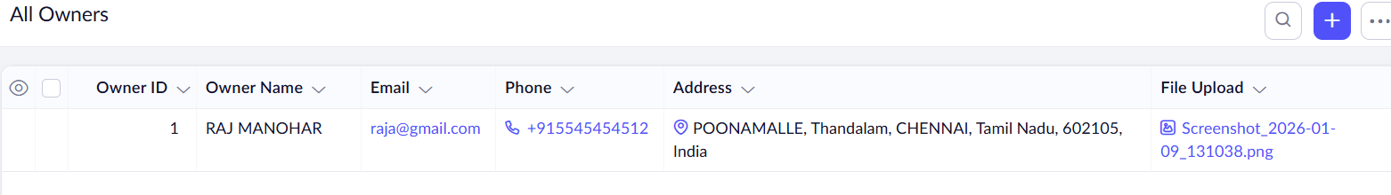
2.
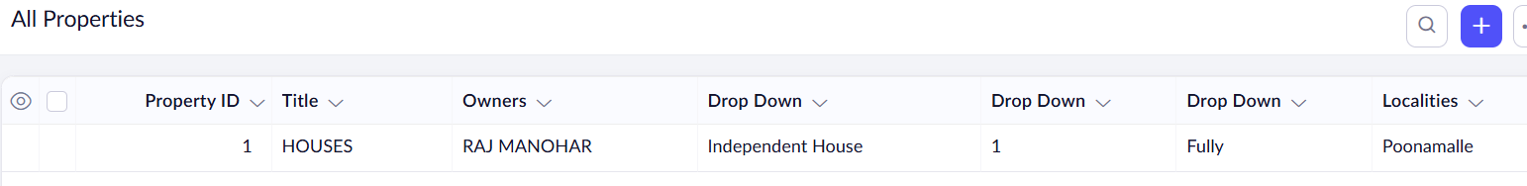
3.
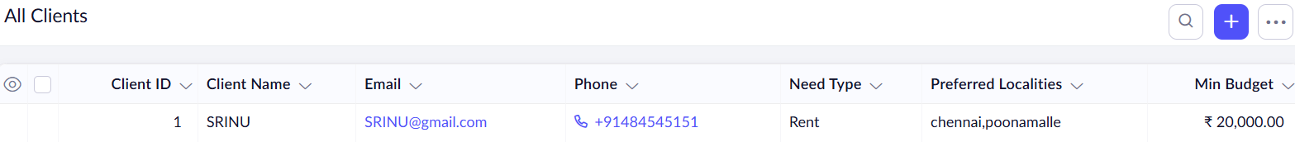
4.
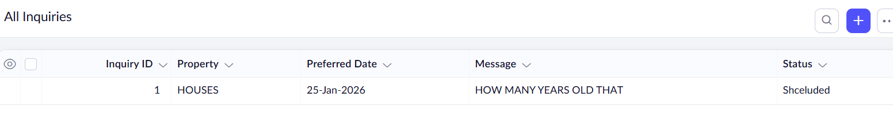
5.


